-----------------------------------------------------------------------------
Button module
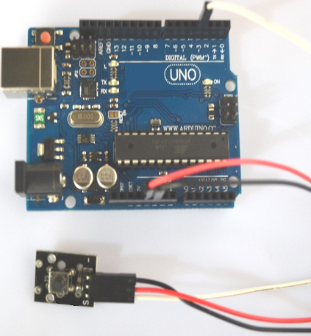

Button module can connect UNO R3 PIN13, make button test.
Pin 13’s LED，use button module connect Pin 3. When button module test there is button single, led can be bright.

Code

int Led=13;//定义LED 接口
int buttonpin=3 //定义按键开关传感器接口
int val;//定义数字变量val
void setup()
{
pinMode(Led,OUTPUT);//定义LED 为输出接口
pinMode(buttonpin,INPUT);//定义按键开关传感器为输出接口
}
void loop()
{
val=digitalRead(buttonpin);//将数字接口3的值读取赋给val
if(val==HIGH)//当按键开关传感器检测有信号时，LED 闪烁
{
digitalWrite(Led,HIGH)
}
else
{
digitalWrite(Led,LOW)
}
}

